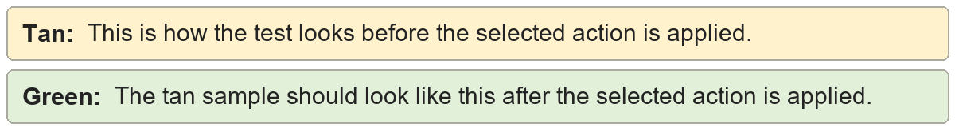
Multiple spaces | This sentence contains repeated spaces.
Multiple spaces | This sentence contains repeated spaces.

Leading and trailing spaces | The sentence is padded.
Leading and trailing spaces | The sentence is padded.

Spaces before punctuation | Hello , world . Why ? Yes !
Spaces before punctuation | Hello, world. Why? Yes!

Spacing after punctuation | First. Second, third: fourth.
Spacing after punctuation | First. Second, third: fourth.

Extra blank lines | Two content lines use paragraph spacing.

Second content line.
Extra blank lines | Two content lines use paragraph spacing.

Second content line.

